# Uploading Your Resume

***If you do not upload your resume, your field coordinator will not be able to match you to a field placement site.***

Click the Documents tab at the top of the page  
Click the '+'

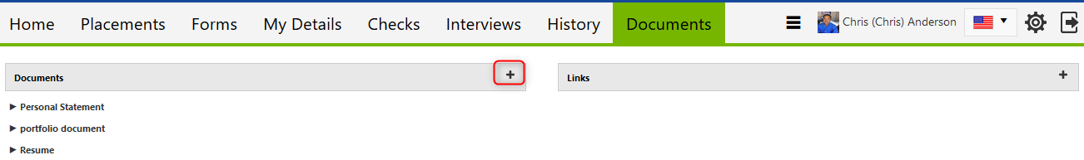

Click ‘Browse’ to look for your resume on your computer

Ensure that you mark "Show to site". If you want your resume to be visible to your liaison, you may also choose “Show to liaison”

Select from the category drop-down menu the resume category based on the program level for your *next* placement (for example, if you are currently in your MSW Generalist placement and you are applying for your MSW Concentration placement you would select Resume – MSW Concentration)

Click the Add button  
  
