Field Application
Click on the Forms tab at the top of the page to access your Field Application. The name of the form will show on a blue horizontal bar. The due date will be listed below the blue bar. Click the red ‘Edit’ button at the right end of the blue bar to complete the form. This should open a new tab.

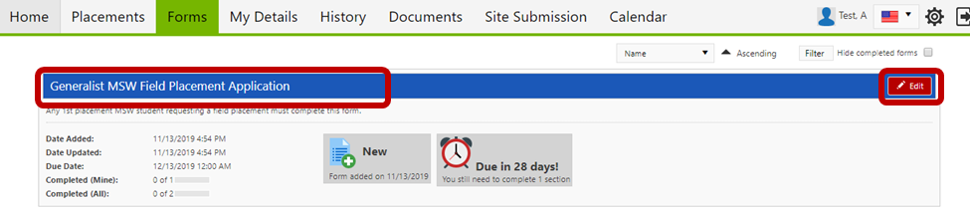

Questions with a red asterisk next to the pencil icon are required

You can save your form at any time by scrolling to the bottom of the document and clicking Save Draft.

Note that if you click Submit without answering all of the required questions, you will get a warning with a list of all of the items left incomplete. Scroll up to get back to the form.

If a form has been Saved but not Submitted, simply click the ‘Edit’ button again to continue. Upon clicking ‘Submit’ on the form, the screen will look like it has a white screen on it for a few seconds – this means the form is saving. Before closing the form, confirm the Submit was processed by scrolling down to where you hit Submit to see “Form actioned by [your name] on [date] at [time]” in green text.

