Field Placement Site Preferences
To select your preferences for your field placement site, go to the Placements Tab at the top of the screen.

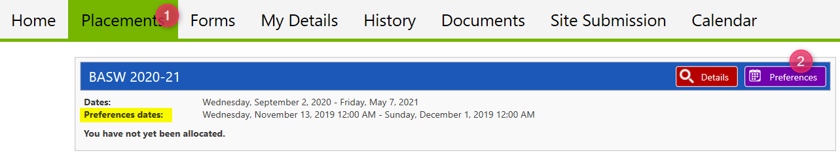

Selecting your preferences
During the dates specified (highlighted in example above), you may search available Sites for a preferred placement.

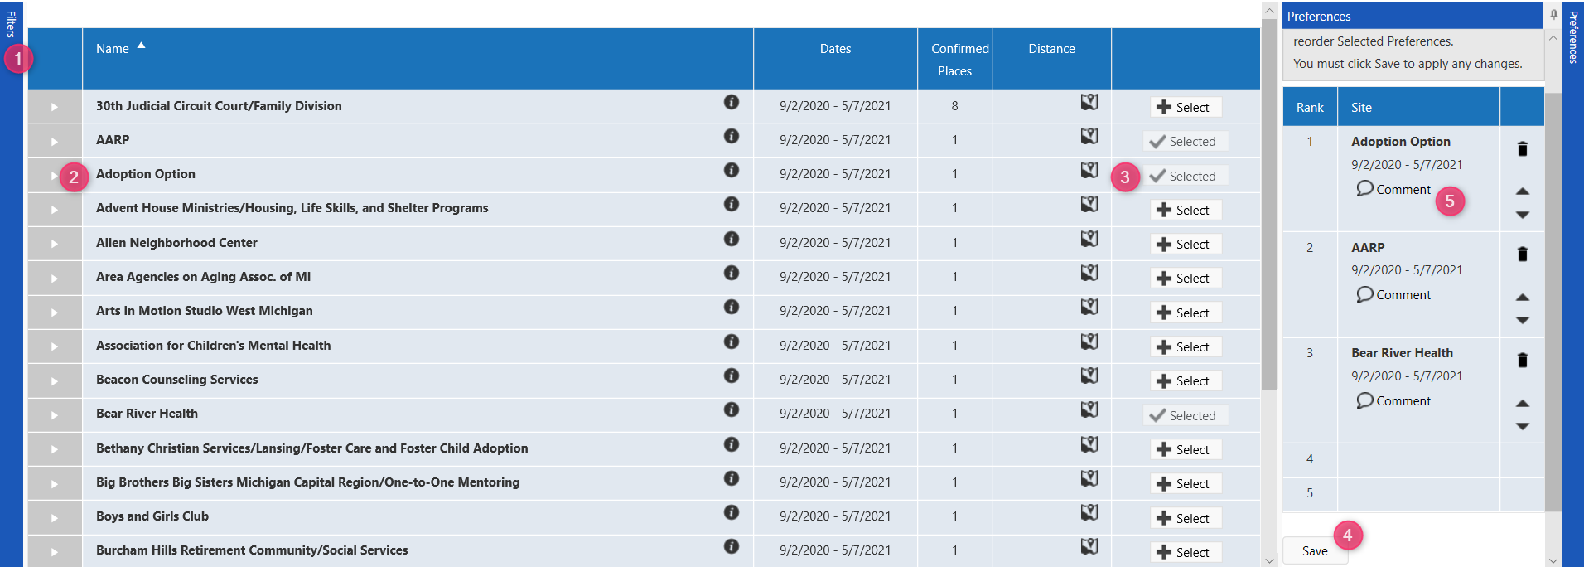
  - Filter your search using the box on the left of the Preferences screen.
  - Click the triangle in the gray box to expand to see details about the Site.
  - Select the Sites that interest you.
  - Save your preferred Sites in the box on the right. You can re-order them by dragging/dropping.
  - When you ‘Save’ your preferences, you will see a balloon icon appear. The balloons are for you to write comments about the site. For example, “This is my #1 choice because…”.

The order in which the Sites appear can be changed by clicking the heading of the column you wish to sort by (e.g., Site details, Places or Distance). It may show the number of places available at the site and the approximate distance to the Site from your home address.

A small “map” icon will open Google Maps to see the route to the Site, while a small “i” icon (information) will open a new search window to find any web information about the Site.

You may find some Sites are highlighted in red. This indicates that the site is unavailable to you. There may be a number of reasons for this; you can inquire with your field coordinator for more information. Keep in mind that Sites which are not red may also be unavailable for a variety of reasons. Your field coordinator will consider your preferences and determine an appropriate match.

